

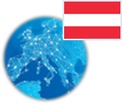 **Austria** *Energy Union factsheet[1]*

1. **Macro-economic implications of energy activities**

Energy and transport are key sectors for the overall functioning of the economy as they provide an important input and service to the other sectors of the economy. Together the activity in these two sectors[2] accounted for 7.3% of the total value added of Austria in 2015. Their share in total employment[3] was 5.5% of total employment in 2015, of which 4.9% in the transport sector and 0.6% in the energy sector.



*(source: Eurostat)*

The decarbonisation of the energy and transport sectors will require significant investments and economic activity beyond the remit of these sectors themselves. The energy transition implies a structural shift in economic activity. Energy-related investment and jobs will in part migrate from traditional fossil fuel based activities towards construction, equipment manufacturing and other services related to the deployment of low carbon and clean energy technologies. At the moment, the efforts related to the low-carbon and clean energy transition in sectors beyond energy can only be partially quantified and are therefore not included in this analysis.

In the case of renewable energy sector, both the direct and the indirect effects on employment are being estimated. According to EurObserv'ER, in 2015, the share of renewable energy related employment in total employment in Austria was at about 0.95% and thereby above the EU average of 0.54%. The turnover of the renewable energy industry in the same year was estimated at around EUR 6.9 billion, the biggest part being attributed to the biomass (EUR 2.0 billion) followed by small hydro (EUR 1.6 billion), wind (EUR 1.1 billion) and photovoltaic (EUR 610 million) industries.

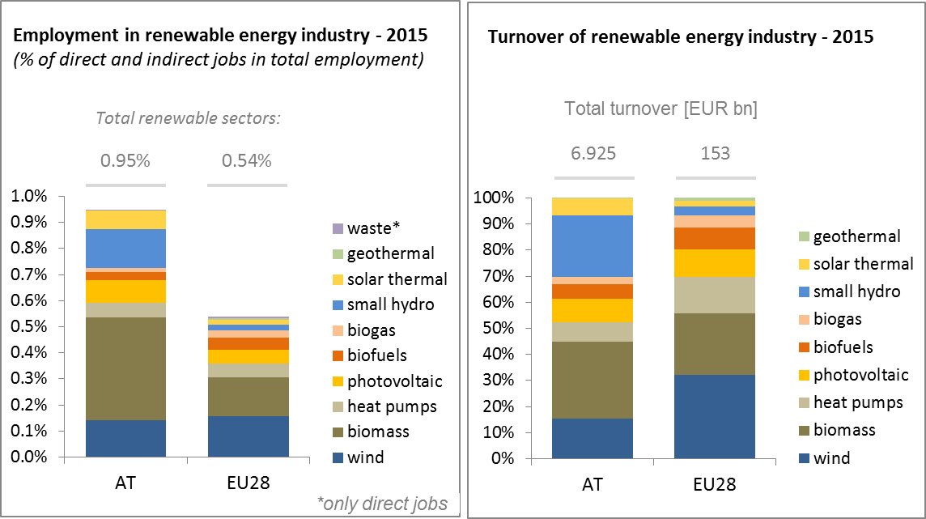

*(source: EC based on Eurobserv'Er and Eurostat)*

An indication of the level of efforts and challenges encountered by Austria in the energy sector is provided by the Gross fixed capital formation (GFCF)[4]. Investments in the electricity and gas sectors, taken as reference sectors, have been fluctuating over the period 2006-2015 but never went above 1% of GDP. In 2015, investment in the electricity and gas sectors was at around 0.7% of the country's GDP, which is roughly the same level as in 2006.

**

*(source: Eurostat)*

In terms of trade, Austria is a net importer of fossil fuels and electricity. The trade deficit in energy products has fallen from about 3.5% of GDP in 2006 to 2.3% in 2015. The electricity trade deficit fell from 0.2% to less than 0.1% of GDP. The trade deficit for oil has also reduced from 2.4% of GDP in 2006 to 1.4% in 2015 reflecting lower prices.

**

*(source: Eurostat)*

1. **Energy security, solidarity and trust**
   1. **Energy Mix**

In comparison to the average energy mix of primary products in the EU, Austria's energy mix has a much higher share of renewable energy (29.8% vs 13%) and no nuclear energy (EU average: 13.6%) in gross inland consumption. Solid fuels have a significantly lower importance in Austria (9.8% vs 16.2%). Consequently, the Austrian energy mix has a lower share of fossil fuels than the EU.

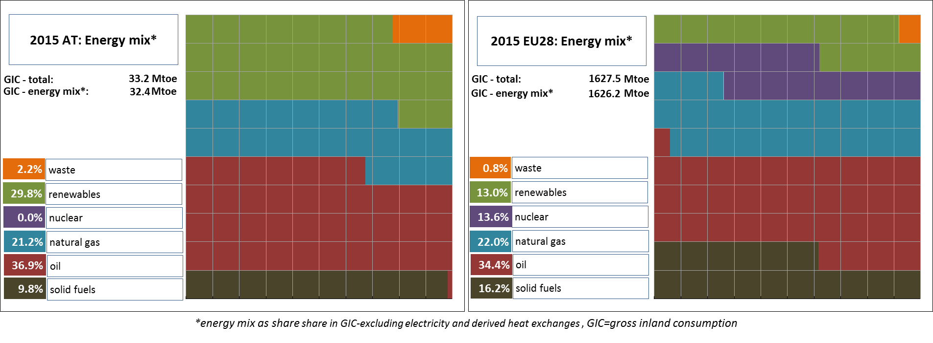

*(source: Eurostat)*

* 1. **Import dependency and security of supply**

60.8% of Austria's energy consumption comes from imports, slightly more than the EU average (measured in gross inland consumption). This is due to the high share of imports of fossil fuels, in particular oil.

The overall import dependency of Austria decreased by about 11 p.p. between 2005 and 2015. At EU level, import dependency increased by 1.9 p.p. over the same period. Austrian import dependency for natural gas and hard coal showed a significant decrease over time. At the same time, the level of the aggregate supplier concentration index (for crude oil, natural gas and hard coal, taking into account imports from outside the European Economic Area) grew by a relatively large extent, pointing to potentially increased vulnerability. The overall decreasing net import dependency can be attributed to the increase in indigenous renewable energy production and a decrease in energy consumption. Natural gas imports come mainly from Russia (2013: 62% - no 2015 breakdown available from Austria). Austria acts as a regional gas hub and its energy security benefits from large underground gas storage facilities.

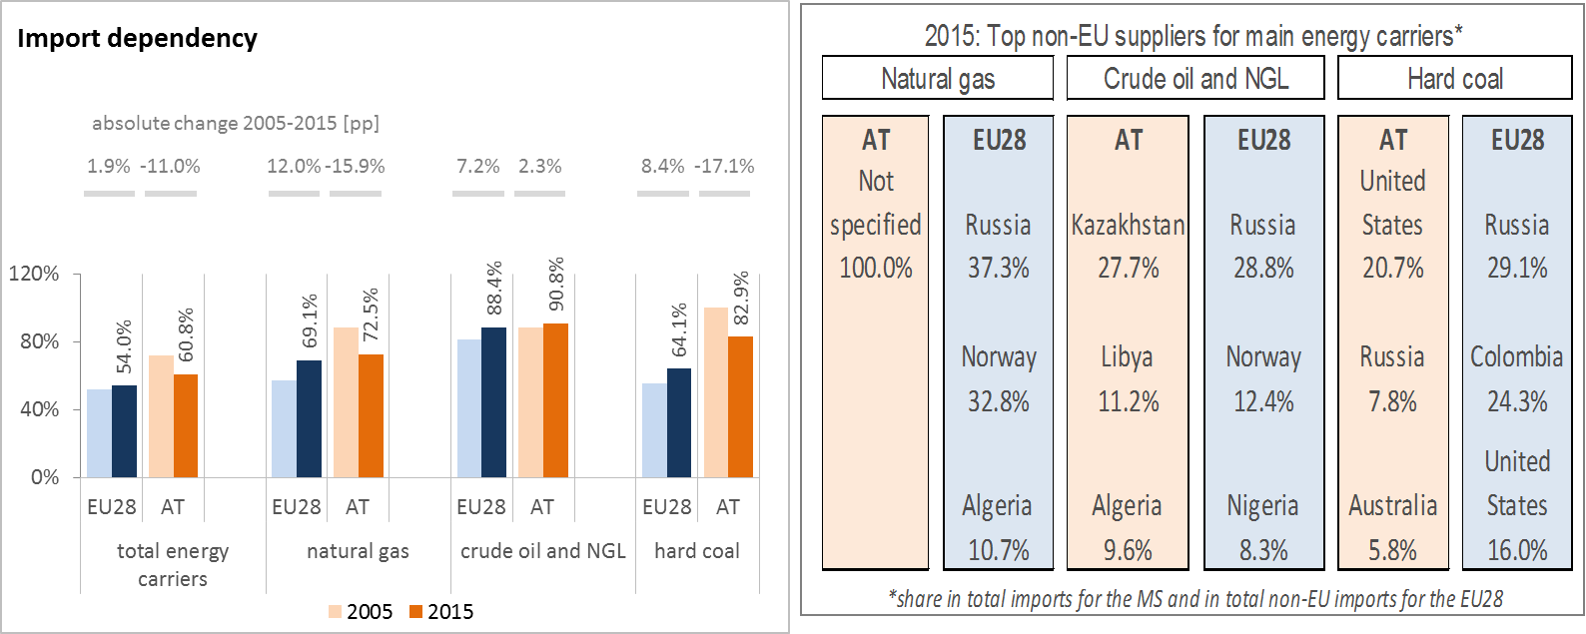

*(source: Eurostat)*

The security of gas supply regulation requires that, if the single largest gas infrastructure fails in one Member State, the capacity of the remaining infrastructure is able to satisfy total gas demand during a day of exceptionally high gas demand. This condition is met if the value of the N-1 indicator is equal to or above 100 %. Austria significantly exceeds the required 100% threshold for its N-1 value. The indicator has even significantly improved over the last years, owing to new pipeline connections with neighbouring countries in Central Europe.



*(source: gas coordination group)*

1. **Internal market**
   1. **Interconnections and wholesale market functioning**
      1. **Electricity**

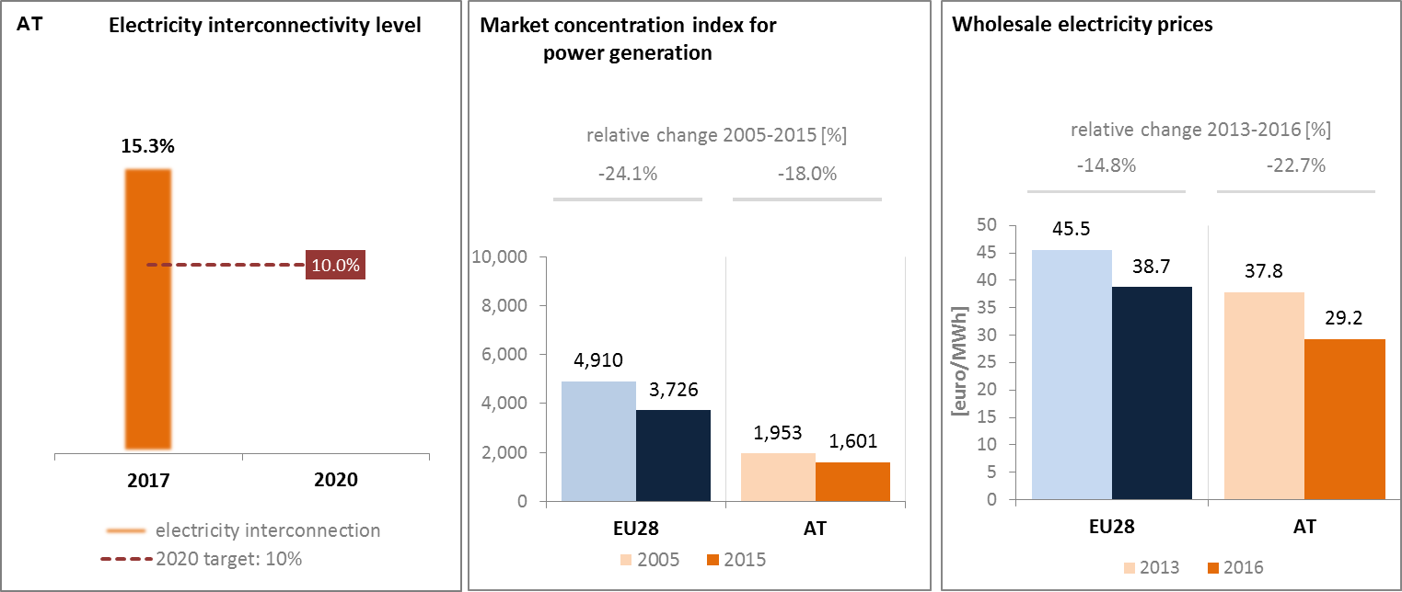

*(source: EC services based on ENTSOE) (source: EC services based on Eurostat) (source: EC services based on Platts and European power exchanges)*

Austria is part of the Central Western European wholesale electricity market and is closely connected with its neighbouring countries. Austria and Germany form a common bidding zone. In 2017, the electricity interconnection level[5] of Austria was 15.3%, well above the 2020 target of 10%.

The central location of the country poses challenges as regards the efficient accommodation of the North-South electricity flows. The Austrian electricity grid needs to accommodate high and increasing production of electricity from solar power and wind. Progress on the reinforcement of domestic and cross-border electricity transmission capacity, supported by the 'project of common interest' (PCI) status of nine electricity projects, has been modest.

Concentration on the power generation market is much below EU average. Due to the close interconnections with neighbouring countries and the common bidding zone with Germany the power market showed comparably low and decreasing wholesale electricity prices. Wholesale electricity prices are among the lowest in the EU, and between 2013 and 2016 recorded a higher decrease than the EU average (22.7% in AT vs 14.8% in EU). In Austria the share of (bigger) generating companies in national electricity generation is around 50%.

* + 1. **Gas**

Wholesale gas prices remain at a similar level as average EU gas prices. Gas market competition, albeit still less developed compared to the leading EU gas markets, showed a strong improvement. Austria is a significant transit country for gas as it is well-located along gas routes from Russia to Italy and Southern Germany. Its transit capacities help to secure the energy supply of its neighbours. Austria´s gas infrastructure is suffering from remaining bottlenecks at certain entry-exit points. Four PCIs in gas are addressing these bottlenecks as well as improved market integration and enabling reverse flows.

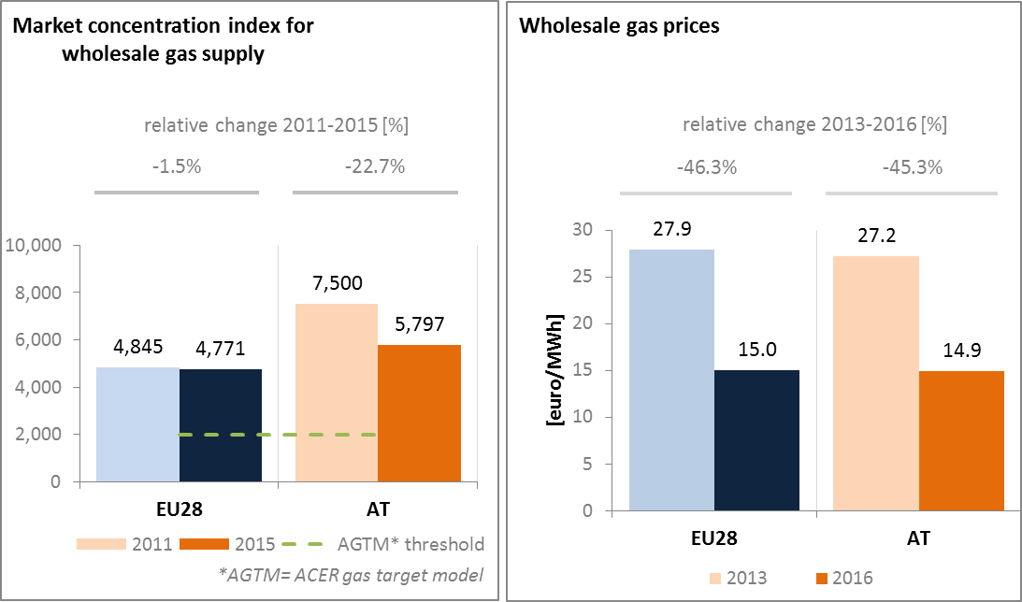

*(source: ACER for the left graph and EC services based on Platts, gas hubs, Eurostat for the right graph)*

* 1. **Retail electricity and gas markets**
     1. **Electricity**

In 2015, household electricity prices in Austria were slightly below the EU average. Between 2013 and 2015, average band retail electricity prices for households decreased, but to a lesser extent than the wholesale prices. This can be partially explained by an increase in taxes and levies, which represent more than a third of average household prices.

Deployment of smart meters in Austria is still rather low (2016: 8.5%) but a roll out to 95% of all customers is planned by 2019. Annual switching rates in Austria include only the voluntary switching from one electricity supplier to another, not switches because of moving or changes of products (i.e. "internal switching").

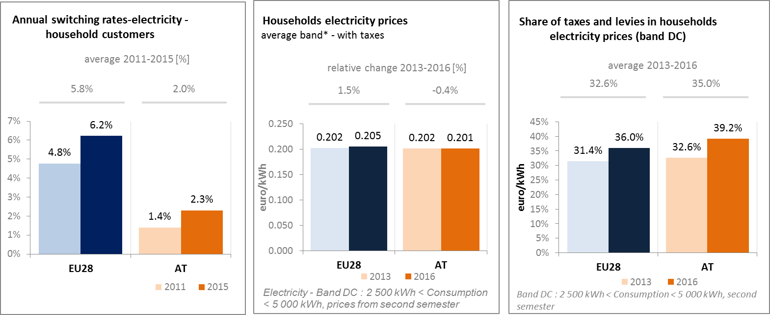

*(source: ACER) (source: Eurostat) (source: Eurostat)*

* + 1. **Gas**

In line with the EU trend, Austrian household gas prices fell by 10.6% between 2013 and 2016. Taxes and levies in household gas prices have been slightly increasing. Also regarding gas, annual switching rates in Austria include only the voluntary switching from one electricity supplier to another, not switches because of moving or changes of products (i.e. "internal switching").

Austria has not yet taken an official decision to proceed with large-scale gas smart metering. Austria has published the minimum standards for the meters but not yet the roll-out plan.[6]

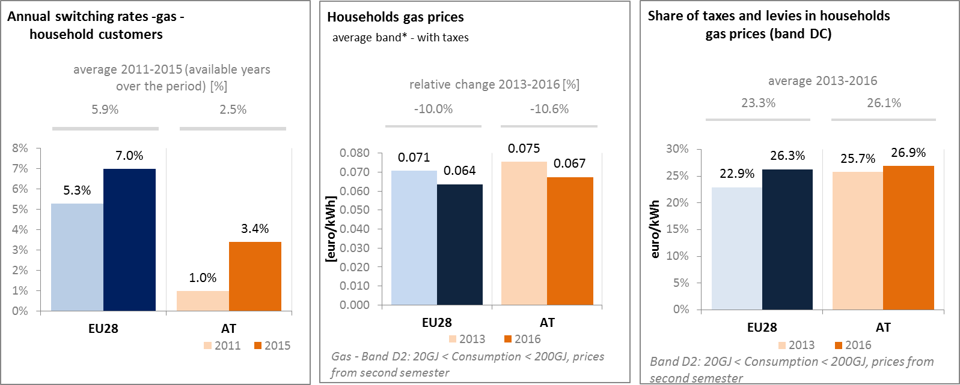

*(source: ACER) (source: Eurostat) (source: Eurostat)*

* + 1. **Market performance indicators**

According to the periodic survey of the European Commission, the satisfaction of the Austrian consumers with the services received on energy retail markets has grown significantly more than the EU average. For both electricity and gas, Austrian consumer satisfaction appears among the highest across the EU.

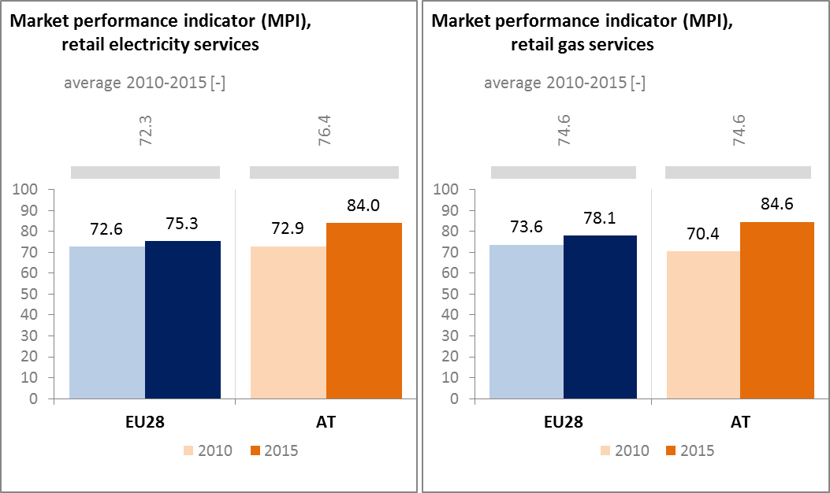

*(source: DG JUST survey)*

* 1. **Energy affordability**

Energy affordability is understood as consumers' ability to pay for their energy needs without this negatively impacting their comfort and livelihood. Affordability can be measured by looking at how much people in the lowest income bracket have to pay for their energy needs (or by calculating the share of energy expenditure in total household expenditure for the quintile of population with the lowest income). In Austria, the share of energy in total household expenditures of the lowest quintile of the population with the lowest income is below the EU average, but has been growing slightly more than the EU average since 2005. Furthermore, only a limited part (8%) of citizens below the at-risk-of poverty threshold considers that they are unable to keep their home adequately warm. This could partly be explained by high energy efficiency standards of residential buildings and low retail electricity prices.

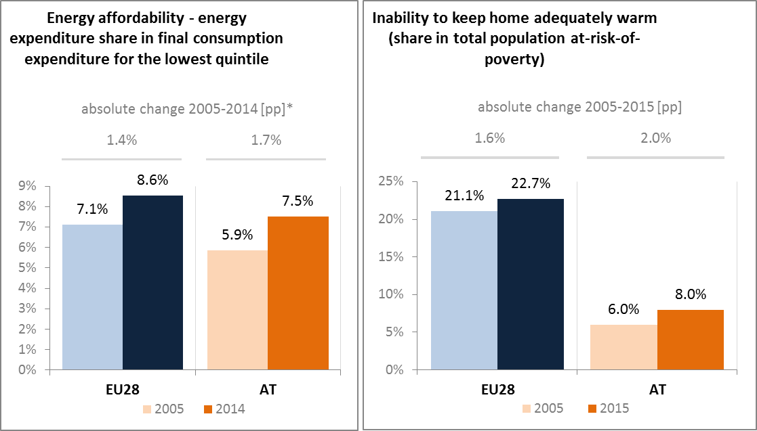

*(source: ad-hoc data collection of DG ENER based on HBS with the support of Eurostat and national statistics)*

1. **Energy efficiency and moderation of demand**

Compared to 2005, Austria decreased its primary energy consumption by 3.3% to 31.33 Mtoe in 2015. Over the same period, final energy consumption also decreased by 1.7% to 27.37 Mtoe in 2015. Austria has to increase its effort to decrease its final energy consumption further in order to achieve its indicative final energy consumption 2020 target (25.1 Mtoe) and to keep its current primary energy consumption below its indicative primary energy consumption 2020 target (31.5 Mtoe). Effective and continuous implementation of the Energy Efficiency Law (adopted on 4 July 2014 in view of transposing the Energy Efficiency Directive) is key in order to use the full potential of energy efficiency in a cost-effective manner in view of reaching the 2020 targets.

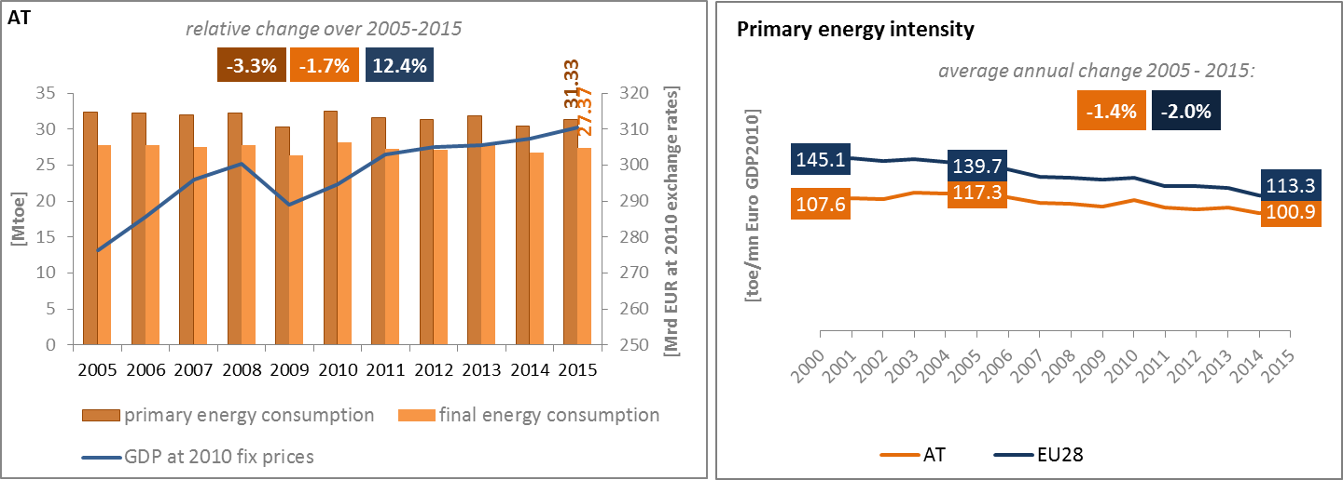

*(source: Eurostat)*

Primary energy intensity in Austria is well below the EU average and has decreased over the 2005-2015 period, although at a slightly slower pace than the EU average. A detailed assessment can illustrate these trends. The energy intensity of Austria's industry is rather stable, but above the EU average, which is linked to a comparatively high share of energy intensive industry in Austria. On the other hand, energy intensity in both the services sector and households is below the EU average. Austria is among the Member States which, between 2005 and 2014, improved the energy intensity in the services sector most.

In 2015, in Austria, industry was the biggest energy consuming sector representing a 33.3% share in the total final energy consumption, which is well above the EU average (i.e. 25.3%). The share of energy consumption of Austria's transport sector was in 2015 at around 33%, which is at EU average. The shares of energy consumption of the residential and the services sectors in Austria are below the EU average, with a share in total final energy consumption of 21.8% and 10% respectively.

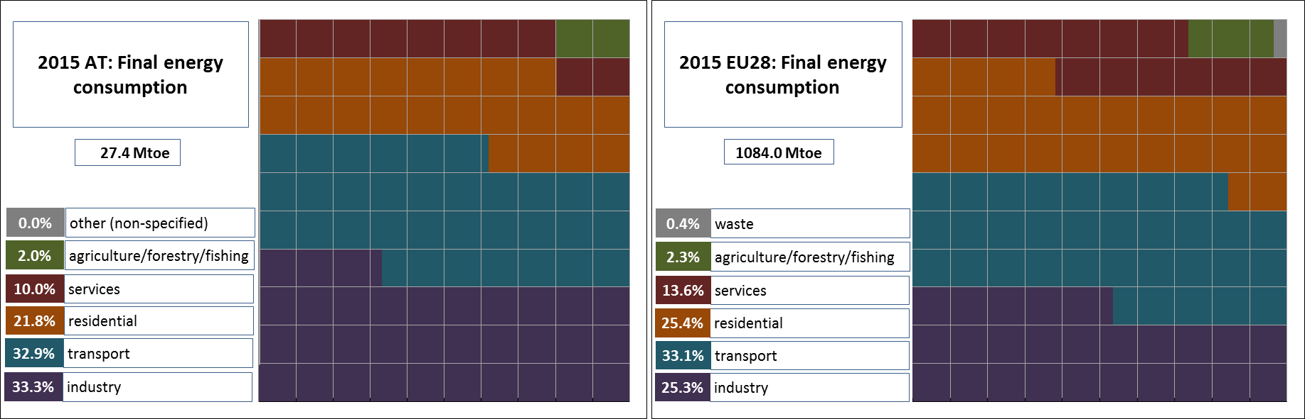

*(source: Eurostat)*

The final energy intensity of Austria's industry is well-above the EU average, notably due to the strong presence of industry, notably steel. Also the residential sector demonstrates energy consumption per square meter above the EU average even after a correction for climate conditions. Additional efforts could therefore be envisaged to improve energy intensity in these demand sectors. At the same time, energy intensity in the services sector has significantly improved in Austria since 2005. Whereas in 2005 it was clearly above the EU average, in 2015 it was clearly below.

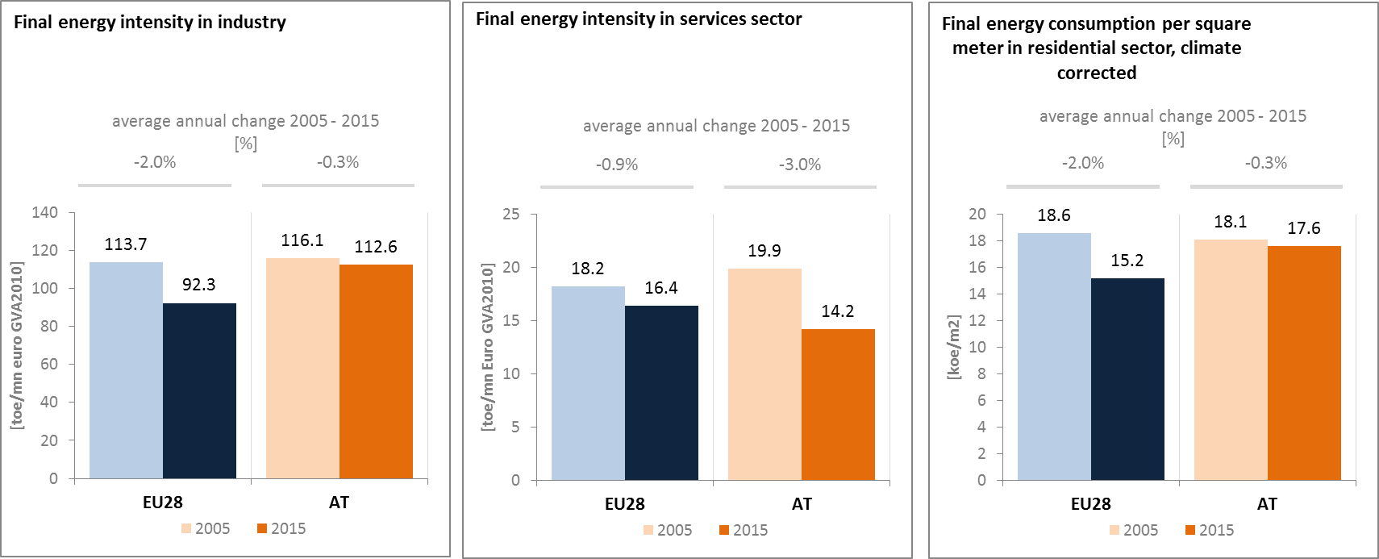

*(source: Eurostat) (source: Eurostat) (source: Odyssee database)*

Between 2005 and 2015 in Austria, the final energy consumption in transport has not changed (i.e. average annual change was 0% over that period) and amounted in 2015 to 9 Mtoe, while GDP increased annually by 1.2 %. Although the initial decrease of final energy consumption (until 2009) was driven by the decrease of freight transport activity affected by the economic context (partially offset by the increase of passengers transport activity), in the subsequent years the increase of transport activity was not reflected in the energy consumption which continues to be slightly below 2005 level.

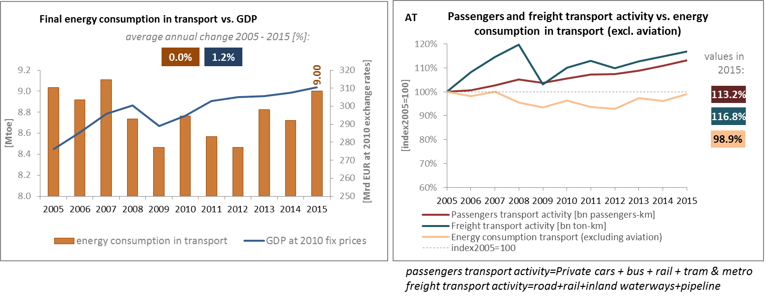

*(source: Eurostat) (source: Eurostat and DG MOVE pocketbook)*

The share of collective land transport in all passengers' transport increased between 2005 and 2015 by 1.6% (from 20.6% to 22.2%), indicating a higher use of collective transport means (including trains, motor coaches, buses and trolley buses) in Austria. This share is above the EU average (of 17.3% in 2015).

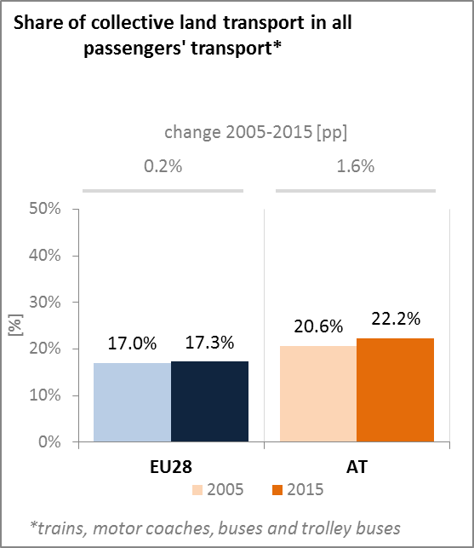

*(source: Eurostat)*

The programme of the previous Government coalition 2013-2017 aimed at strengthening the national transport scheme and the further development of strategies across all modes of transport. The priority areas for action included extending and modernising transport infrastructure, increasing the attractiveness of public transport, implementing plans for innovative mobility, strengthening water ways and extending flood protection.

Austria is situated at the crossroads between Eastern and Western Europe and between Southern and Northern Europe. It is a transit country with a sizeable share of transit traffic, and around two thirds of all transit activities are by road. Austria wants to reduce transit traffic by road as much as possible and a number of restrictions are in place. One of the objectives of the Austrian transport policy is to increase the modal share of rail in freight transport from around one third today to 40% by 2020; the share of road is to reduce correspondingly.

1. **Decarbonisation of economy**
   1. **GHG emissions**

According to its most recent projections, Austria will fail to meet its target in the sectors not covered by the ETS in 2020 if it does not implement additional policies.

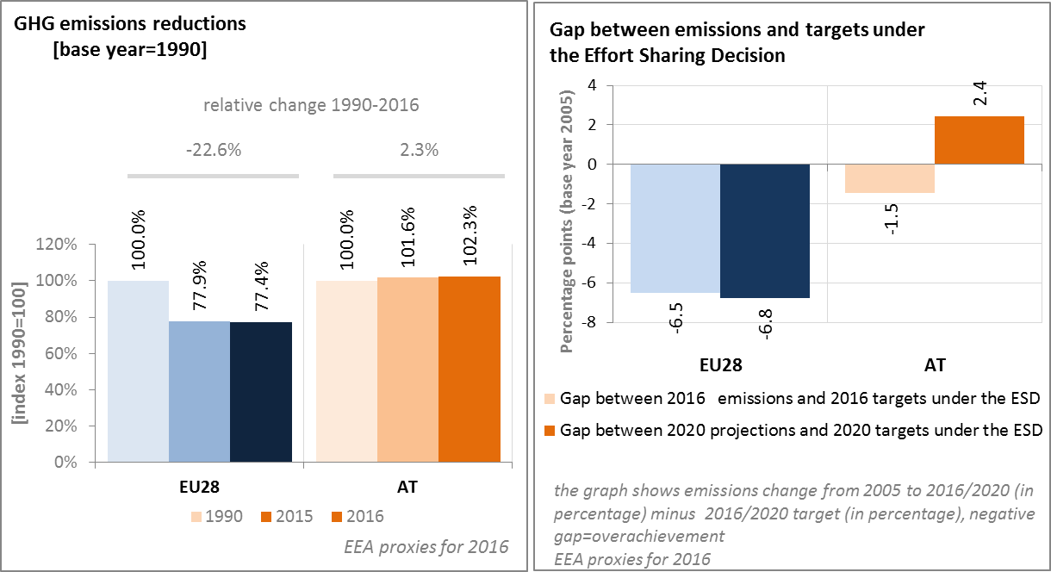

*(source: EC and EEA)*

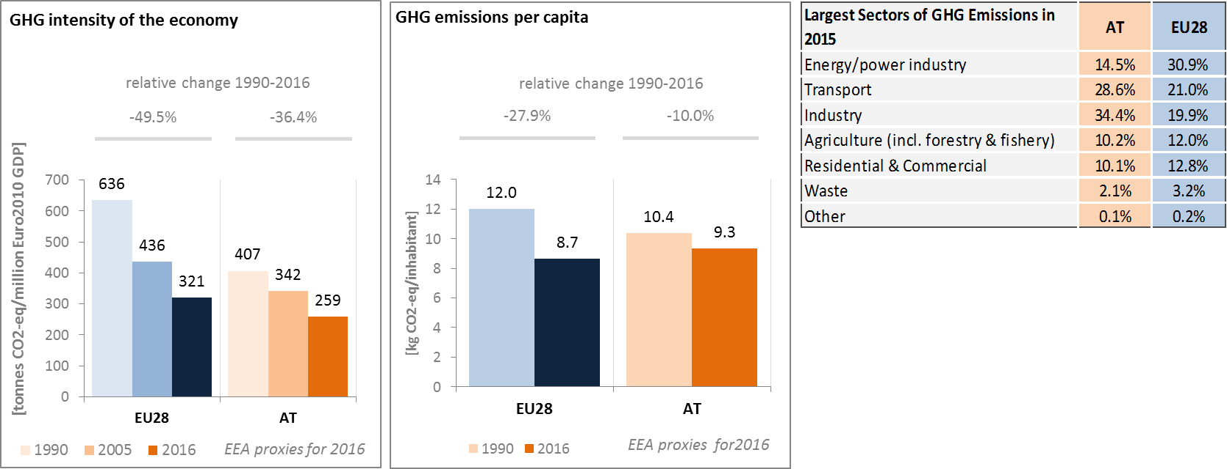

*(source: EC and EEA)*

Preliminary accounts under the Kyoto Protocol for Austria show overall removals of 4.2 Mt CO2eq. as an annual average in the period 2013-2015. For comparison, the annual average of the EU-28 accounted for removals of 119.0 Mt CO2eq. It should be noted that in this preliminary simulated accounting exercise, removals from Forest Management were capped to 2.7 Mt. CO2eq. per year, due to slightly exceeding the limit of the difference between the reported sink and the accounting forest management reference level.

Removals by Afforestation are notably higher than emissions by Deforestation; however, removals by Forest Management contribute the highest share. Overall, removals by Afforestation and emissions by Deforestation remain nearly constant over the course of the three-year period.

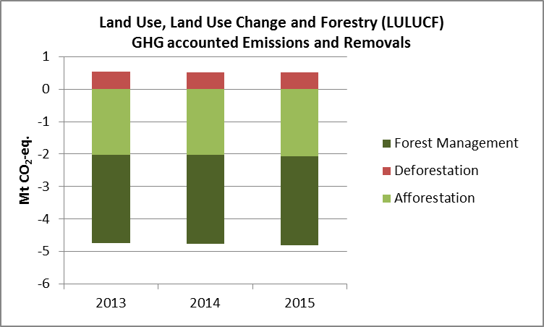

*Note: Forest Management credits are capped and presented as yearly averages when the total Forest Management credits of the considered period exceed the simulated cap over the same period. (source: EC and EEA)*

**CO2 emissions in transport and alternative fuelled vehicles**

The average CO2 emissions of new cars in Austria were in 2016 above the EU average, but decreased between 2005 and 2016 by 25.7% (i.e. slightly less than the EU average of 27.3%).

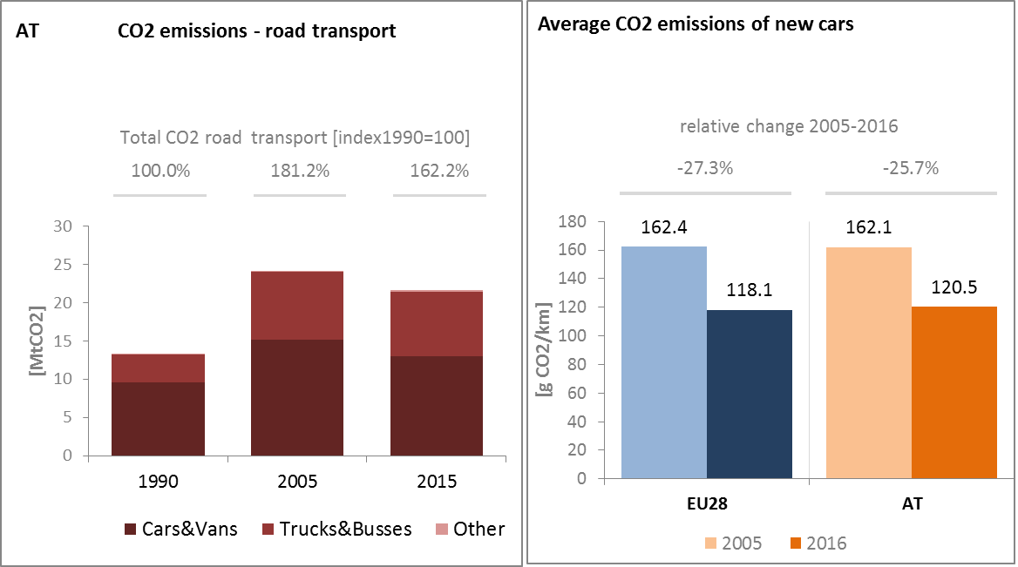

*(source: European Environment Agency)*

The share of alternative fuel cars in total sales on the Austrian market is still marginal (i.e. 1.13% in 2015) but more than twice as much as in 2013. In 2015, 0.9% of new cars in Austria have been hybrid-electric and electric.

The number of electric charging points in Austria has increased significantly over the period from 2013 to 2016 when the number of charging points reached 2476.

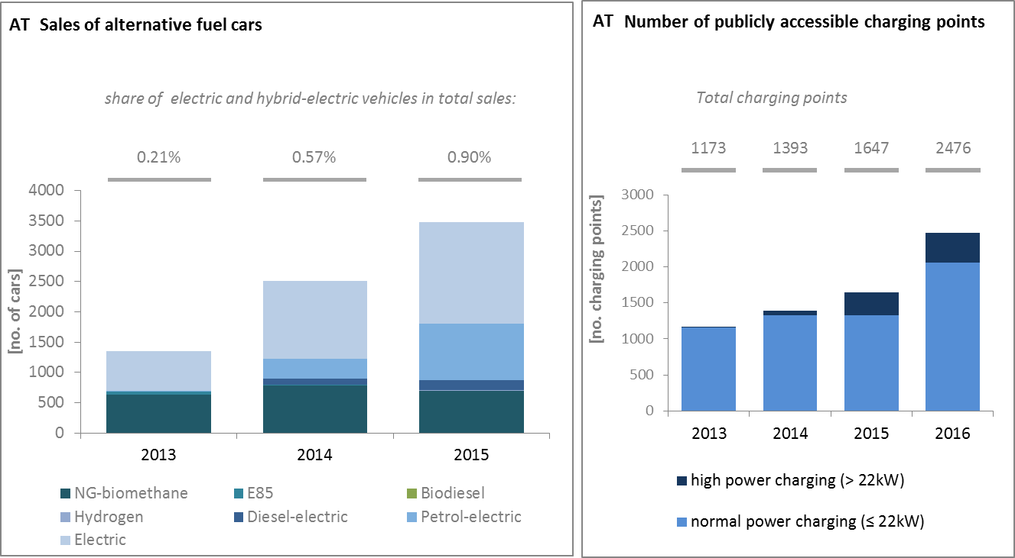

*(European Environment Agency) (European Alternative Fuels Observatory)*

National Policy Frameworks under Directive 2014/94/EU on alternative fuels infrastructure have to establish targets, objective and measures for the development of the market of alternative fuels in the transport sector and the deployment of the relevant infrastructure. Austria has submitted its National Policy Framework as requested under article 3 of the Directive 2014/94/EU.

A detailed assessment of the Austrian National Policy Framework in terms of its compliance with the requirements of Directive 2014/94/EU on alternative fuels infrastructure, its contribution to achievement of long-term energy and climate objectives of the Union and coherence of its targets and objectives in terms of cross-border continuity has been published as part of the Communication on Alternative Fuels Action Plans (COM(2017) 652) and  the related staff working document SWD(2017) 365.

* 1. **Adaptation to climate change**

The Federal Government of Austria adopted a National Adaptation Strategy (NAS) in October 2012 (the Federal States in May 2013), which contains a Strategic Framework and an Action Plan. A qualitative vulnerability assessment allowed for presenting adaptation options for 14 areas for action: agriculture, forestry, water resources and water management, tourism, energy, protection from natural hazards, construction and housing, disaster risk management, health, ecosystems and biodiversity, transportation infrastructure, spatial planning, business/trade/industry, and cities. A monitoring and reporting system is in place since 2015 to assess the implementation of adaptation measures for these vulnerable sectors.

* 1. **Taxes on energy and transport**

The overall tax burden on energy and transport in Austria amounts to 2.4% of GDP, which is in line with the EU average. The overall structure of the energy and transport revenue in Austria has remained stable since 2007. As compared to the EU average, the tax burden on transport vehicles is higher, while fuel taxation is slightly below the average. Taxation of heat and electricity in 2007 was in line with the EU average, while by 2014 it had fallen below the EU average which had increased by around 50%. There is no CO2 component in the tax framework for energy products in Austria, while there is a malus-bonus system based on CO2 for some categories of vehicles.



*(source: Eurostat)*

Austria applies a Car Registration Tax based on fuel and CO2 emissions. Electric cars benefit from an exemption if certain conditions are met. Furthermore, as of January 2016, electric vehicles (zero emission vehicles) are exempted from a taxation rule according to which non-electric company vehicles that are also used privately are subject to a monthly tax amounting to 1.5-2% of the acquisition value.

Austria has decreased its support to fossil fuel in the last decade and in particular in the most recent years, mostly by getting rid of some tax exemption and rebate systems. Several consumer support schemes to fossil fuel were stopped in 2012 (Energy Tax Exemption for LPG Used in Public Transport, Energy Tax Relief for Diesel Used by Trains).



*(source: OECD Inventory of Support Measures for Fossil Fuels 2015)*

* 1. **Renewable energy**

Austria is well on track, and close (2015: 33%) to attaining its renewable energy target for 2020 (34%).

Austria is among the few EU MS which already achieved the renewable energy share in transport reaching 11.4% in 2015. The renewable energy share is 32% in heating and cooling sector. With more than 70% renewable share in electricity generation (mainly hydro but increasingly wind and solar), Austria is still leading in the EU.

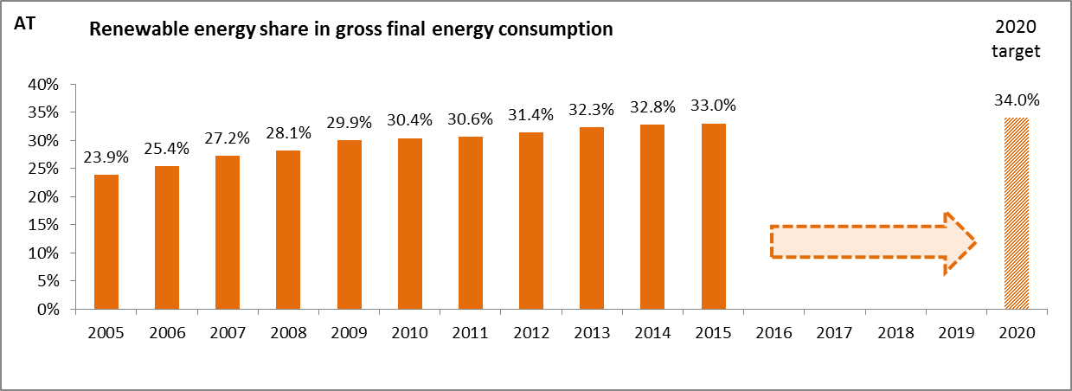

*(source: Eurostat-SHARES)*

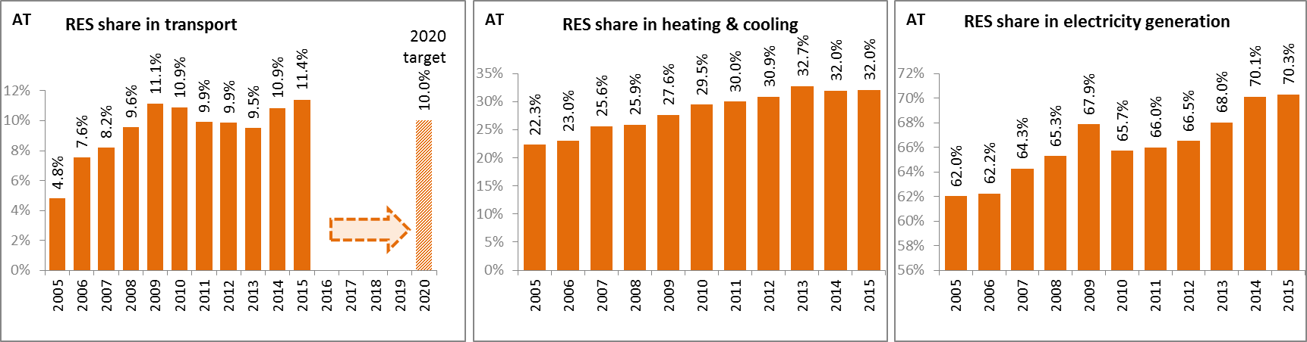

*(source: Eurostat-SHARES)*

In Austria electricity from renewable energy sources is mainly promoted through a feed-in tariff and investment grants. The cost of renewables support schemes is financed through network usage charges, metering point charges, network losses charges, costs for guarantees of origin and revenue from the allocation of green electricity at the day-ahead hourly spot market price. In the heating and cooling sector, investment incentives are applied at the level of individual federal states for solar thermal installations, heat pumps, geothermic and biomass heating plants.

Renewable energy in transport is promoted with a substitution system which obliges companies bringing fossil fuels onto the Austrian market to substitute a certain percentage of their annual fuel sales. Furthermore, biofuels are supported through a fiscal regulation mechanism.

Due to a consistent deployment of renewables since 2005, it is estimated that Austria avoided in 2014 about 13.4% of the fossil fuel in gross inland consumption and about 11.8% of GHG emissions at national level. [7]

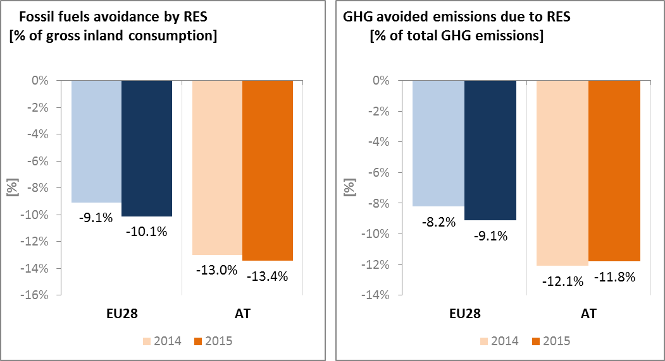

*(source: EEA)*

* 1. **Contribution of the Energy Union to better air quality**

The emissions of several air pollutants have decreased significantly in Austria. Notwithstanding, air quality in Austria continues to give cause for concern. For the year 2013, the European Environment Agency estimated that about 6,960 premature deaths were attributable to fine particulate matter (PM2.5) concentrations and 910 to nitrogen dioxide (NO2) concentrations[8].

For both pollutants Austria reported exceedances of the binding EU air quality standards[9]. For the year 2015, Austria reported exceedances of the limit value for PM10 in 2 out of the 11 air quality zones in Austria, while exceedances of the limit value for NO2 were reported in 7 out of the 11 zones[10].

**

*(source: EEA)*

In the Commission's EU Environmental Implementation Review Report for Austria[11], the health-related external costs from air pollution in Austria have been estimated to be more than EUR 5 billion/year (income adjusted, 2010), which includes the intrinsic value of living a healthy life without premature death as well as the direct costs to the economy such as healthcare costs and lost working days due to sickness caused by air pollution.

The Energy Union can substantially contribute to addressing these air quality problems through measures reducing emissions of both greenhouse gases and air pollutants such as PM and nitrogen oxides (NOx) from major contributing sectors such as (road) transport, energy production, industry and residential heating (e.g. stoves and boilers)[12].



*(Source: EEA. This table reflects only sources of primary PM2,5 emissions.)*

1. **Research, innovation and competitiveness** 
   1. **Research and innovation policy**

The Climate and Energy Fund of the Federal Government has been the main source of government funding for energy research since 2007. The Climate and Energy Fund is maintained by the Federal Ministry for Transport, Innovation and Technology (BMVIT) and the Federal Ministry of Agriculture, Forestry, Environment and Water Management (BMLFUW). Sub-programmes under the Climate and Energy Fund are: New Energies 2020, Smart Energy Demo – fit4SET, and Technology Lighthouses for Electromobility in Austria.

Most energy research funding is managed by the Austrian Research Promotion Agency at the operative and administrative level, on behalf of the Climate and Energy Fund, the BMVIT and the Federal Ministry of Science, Research and Economy (BMWFW). Further support activities are driven directly by the ministries in the form of subsidies, research contracts, and special actions like prizes and awards.

Within the framework of the strategy process e2050, an Energy Research Strategy for Austria (Energieforschungsstrategie für Österreich, 2010) has been developed by BMVIT together with the Austrian Research Council. Numerous experts from industry and research facilities were involved in the elaboration of the Strategy.

According to the Strategy, energy research in Austria has three main pillars: energy efficiency, renewable energy and security of supply. This framework is designed to create a mix of energy sources and raw materials to ensure security of supply, cost-effectiveness, and environmental and social acceptability. In particular, the Strategy focuses on energy-efficient buildings, logistics and mobility, energy-efficient technologies for final energy use, sociological and ecological research, life-cycle analysis, foresight studies, energy storage and distribution, smart grids, process heat from renewable sources, biofuels, and transport.

Austria is an active contributor to the ongoing work of the Strategic Energy Technology (SET) Plan. It participates in seven (out of fourteen) temporary working groups for the implementation of the integrated SET Plan, leading the one on smart cities and communities and co-leading energy systems.

Regarding the Horizon 2020 programme, Austria has so far received 4.4% of the EU contribution devoted to the 'secure, clean and efficient energy' part of the programme. As of September 2017, 183 organisations from Austria have been awarded EUR 80 million in Horizon 2020 energy projects. This includes a grant of EUR 3.8 million to Voestalpine Stahl for its participation in project H2Future (hydrogen electrolysis demonstration plants), and eight grants totalling over EUR 7.8 million to Austrian beneficiaries participating in project SMARTER TOGETHER (smart and inclusive solutions for urban districts).

* 1. **Investments on Energy Union R&I priorities and patents**

In 2015, public (national) investments in the Energy Union R&I priorities reached EUR 128 million; a decrease of 10% compared to 2014. The highest share of investments (42%) was attracted by the Smart System priority of the Energy Union, followed by the Efficient Systems (27%) and Sustainable Transport priorities (19%). In the period 2007–2015, the maximum annual public investment was EUR 143 million, reported in 2014. For the same year, the most recent year for which data for most EU Member States are available, public investment per GDP in Austria was higher than the EU average.

Private investment in the Energy Union R&I priorities in 2013 was estimated at EUR 418 million (3% of the private R&I investment in Energy Union R&I priorities in the EU). The focus was on the Smart System priority, which received 34% of these investments, followed by Sustainable Transport with a share of 26%.

In 2013, the most recent year for which complete patent[13] statistics are available, 90 companies and research organisations based in Austria filed 170 patents in low-carbon energy technologies (3% of the EU total). The focus was on Smart System (35%), followed by the Sustainable Transport and Efficient Systems priorities (24% each).

In 2013, private R&I investments and patents in Energy Union R&I priorities were higher than the EU average when normalised by GDP and by population respectively. In the period 2007–2013, both private R&I investments and the number of patents in Energy Union R&I priorities increased, on average, by 5% and 14% per year, displaying lower rates of increase than the the EU average (6% and 15% respectively).

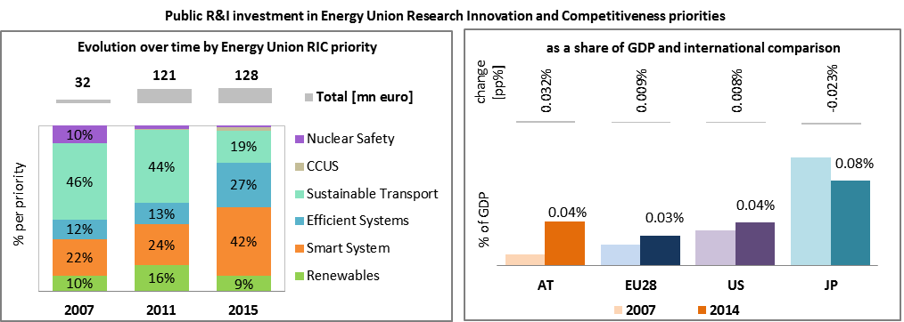

*Note: The international comparison (right) is shown for 2014 (Austria had reported EUR 143 million). Reporting at EU level for 2015 is not as complete, and very few countries have reported for 2016.* 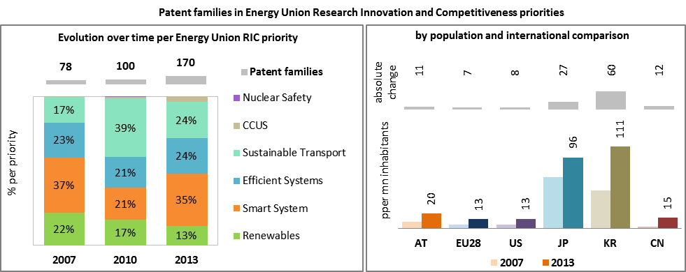

*(Data sources: Public investment as available in the International Energy Agency RD&D Statistics database[14] for codes relevant to Energy Union RIC priorities. Patent data based on the European Patent Office PATSTAT database[15]. Private investment as estimated by JRC SETIS. Detailed methodology available from the JRC[16].)*

* 1. **Competitiveness**

In 2014, the real unit energy costs (RUEC)[17] in Austria (12.7) were below those at the EU average (15.3), close to twice as high as in the US but below those in Japan and China. The electricity prices paid by industrial customers in Austria are below the EU and OECD averages. In line with this, maximum, median and minimum prices are all slightly below the EU averages. While the Austrian median price compares favourably with the prices in Switzerland or Japan, it remains slightly above the OECD average.

Gas prices for industrial consumers are slightly above the EU and OECD averages. It is noticeable that the Austrian minimum price is at the level of the EU average.

These results indicate that Austria has a good rate of energy efficiency in its industry (the RUEC is low), despite a significant proportion of energy-intensive industry.

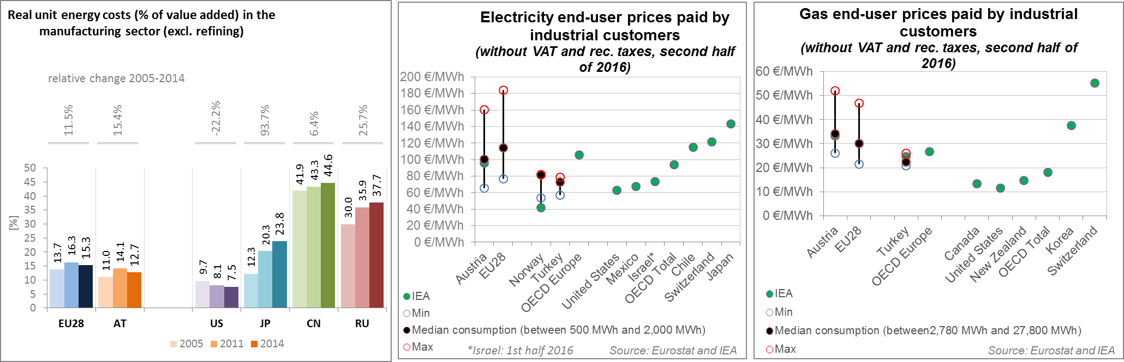

*(source: ECFIN) (source: ESTAT and IEA)*

Regarding the competitiveness in solar energy, as indicated by the revealed comparative advantage indicator[18] below 1, Austria is not specialised in solar PV and is performing slightly below the EU average. The relative trade balance[19] shows that Austria was a net importer of solar components in 2015, roughly in line with the EU average. On the other hand, as indicated by a revealed comparative advantage indicator above 1, Austria is specialised in wind energy technologies, especially in wind turbine power electronics. Nonetheless, Austria's performance fell in 2015 with respect to 2005 and reached a level below EU average. In 2005 Austria was a net exporter of wind components, while in 2015 the trade balance was roughly equal to zero. The trade surplus generated by the export of power electronics just compensated for the trade deficits accumulated in other parts of the wind turbine technology chain.

* (source: UN comtrade)*

1. **Regional and local cooperation**

Austria is member of several regional groups:

Austria is a member of the High Level Group on Central East South Europe Connectivity (CESEC). The main aim of the group is to coordinate efforts to facilitate cross-border and trans-European projects that diversify gas supplies to the region, as well as to implement harmonised rules. Austria, as a regional gas hub, has an important role there.

Austria's electricity market is part of the Central-West Europe Flow-Based Market Coupling. The recent agreement with German authorities on the introduction of capacity allocation at the border between Austria on the one hand and Germany on the other hand can provide clarity for the interim period, until coordinated regional capacity calculation within a European legal framework is finalised. Bilateral agreements however cannot replace the need for an objective, coordinated regional process based on technical power system constraints and involving competent regulatory authorities of all affected Member States.

The Pentalateral Forum was created in 2005 by Energy Ministers from Benelux, Germany and France (with Switzerland as a permanent observer) in order to promote collaboration on cross-border exchange of electricity. The Forum focusses its work on flow based market coupling and security of supply, notably, regional adequacy forecasts and a regional network capacity plan. In 2011 Austria joined the Pentalateral Energy Forum, that is since sometimes referred to as PENTA+.

The TEN-E groups for electricity (North-South Interconnections [NSI] West Electricity, NSI East Electricity) and gas (NSI East Gas, Southern Gas Corridor) have successfully adopted a regional list of PCIs which constituted the basis for the preparation of the EU-wide lists in 2013 and 2015.

The voluntary technical regional initiatives on electricity (Electricity Regional Initiative [ERI] Central East, ERI Central-South) and gas (Gas Regional Initiative South-South East) focus on developing and testing solutions for cross-border issues, regarding (early) implementation of the EU energy acquis or initiating pilot-projects that can be exported from one region to the other.

Austria is also member of the only regional group existing for oil (Oil Supply Connections in Central-Eastern Europe [OSC]).

Austria also participates in the Germany-led round table on market developments.

The EU macro-regional strategies for the Danube Region and Alpine Region in which Austria takes part can be used as a basis for regional cooperation on energy. European Territorial Cooperation – 'Interreg' – under EU cohesion policy also provides further opportunities for cross-border, transnational and interregional cooperation, including in the Energy Union areas.

Cities and urban areas have a key role in the energy and climate challenge. The Urban Agenda for the EU, established by the Pact of Amsterdam in May 2016, better involves cities in the design and implementation of policies, including those related to the Energy Union. It is implemented through Partnerships, in which the Commission, Member States, cities and stakeholders work together on a number of important areas, including on Energy Transition, Urban Mobility, Air Quality, Climate Adaptation and Housing. Austria is participating in the partnership on Housing, with the city of Vienna as co-coordinator.

Austria is very active and contributes to many projects, also at EU level, under the European Covenant of Mayors. 26 Austrian cities (including Vienna) are signatories of the European Covenant, representing approx. 23% of Austria's population. An example is the project "Green social housing for all" in Vienna, as part of which low-energy consumption has become the rule in new houses, with more and more reaching “passive house standards”. Already in 2010, 20 to 30% of the new homes were built to passive house standards. The city's CO2 reduction target is 21% by 2020.

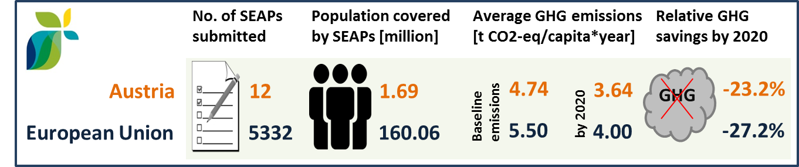

*(source: JRC 2016. Notes: SEAP=sustainable energy action plan, GHG=greenhouse gas emissions)*

In Austria, by September 2016, one city (covering 0.01 million inhabitants) has committed to conduct vulnerability and risk assessment and develop and implement adaptation plans in the framework of the Covenant of Mayors for Climate and Energy.

1. **Cohesion policy and EU-supported clean energy investments**

EU cohesion policy makes a key contribution to delivering the Energy Union objectives on the ground, including investment possibilities to implement energy policy objectives in Austria which are complemented by national public and private co-financing, aiming at optimal leverage. It also ensures integrated territorial solutions to energy and climate challenges, supports capacity building and provides technical assistance.

Over 2014-2020, cohesion policy is investing some EUR 81 million in energy efficiency improvements mainly in enterprises, but also in public and residential buildings in Austria. Cohesion policy is also investing significantly in R&I and in SME competitiveness in Austria, based on the national strategy as well as regional strategies for smart specialisation. For Austria, the strategies include a focus on energy and environment, material and production as well as mobility. At this stage, at least EUR 17 million is foreseen for investments in R&I and adoption of low-carbon technologies in Austria but this might increase further in line with the evolving content of the smart specialisation strategy. A further estimated EUR 5 million is invested in supporting the move towards an energy-efficient, decarbonised transport sector in urban areas.



*(source: DG REGIO)*

Overall, the cohesion policy investments in Austria over 2014-2020 are expected to contribute to an estimated annual decrease of GHG emissions of around 213,000 tonnes of CO2eq.

For example, the ‘Research center Energetikum – Living Lab’ jointly run by Burgenland Research Center and the Fachhochschule Burgenland is a multifunctional centre where research is carried out on the premises while the building functions as both an energy supplier and a storage centre. It focuses on a number of individual technologies, such as solar and photovoltaic systems, heat pump systems, storage technologies, as well as developing a system-wide control engineering strategy that takes user behaviour into account. The project cost, including support from the European Regional Development Fund (ERDF), amounted to EUR 584,000.

Through its support to sustainable transport systems, the Connecting Europe Facility (CEF) also contributes to the goals of the Energy Union. Following the Austrian participation in the CEF – Transport 2014–2015 calls, the Austrian action portfolio comprises 28 signed grant agreements, allocating EUR 738.5 million of actual CEF Transport Funding to Austrian beneficiaries (state: February 2017)[20]. The transport mode which receives the highest share of funding is rail (89.3% of actual funding). In the rail sector four main areas of intervention can be identified: the Brenner Base tunnel, the Koralm railway line on the Baltic-Adriatic Corridor, the completion of the works on the cross-border section with Germany and The European Railway Traffic Management System (ERTMS).

The main focus for the Austrian road actions is to overcome cross-border bottlenecks both on the road connection between Vienna and Brno (Czech Republic) on the Baltic-Adriatic Corridor and on the border between Austria and Slovenia with the Karawankentunnel. In the field of Cooperative Intelligent Transport Systems and Services (C-ITS), Austria is an active part of "C-Roads", a platform of Member States working on the deployment of C-ITS services. Austria is also involved in Europe wide actions promoting the use of alternative fuels through Hydrogen Refuelling Stations and ultra-fast electric charging stations.[21]

1. The indicators used in this country factsheet largely build on indicators developed for the Commission Staff Working Document "Monitoring progress towards the Energy Union objectives – key indicators" (SWD(2017) 32 final) <https://ec.europa.eu/commission/sites/beta-political/files/swd-energy-union-key-indicators_en.pdf>
2. Gross value added and employment in NACE sectors D-Electricity, gas, steam and air conditioning supply and H-Transportation and storage
3. National accounts, Eurostat
4. Gross fixed capital formation consists of resident producers´ acquisitions, less disposals, of fixed tangible or intangible assets. This covers, in particular, machinery and equipment, vehicles, dwellings and other buildings. It also includes foreign direct investment (FDI). Steam and air conditioning supply are also included in the figures mentioned above as Eurostat reports electricity, gas, steam and air conditioning supply together.
5. The interconnectivity level is calculated as a ratio between import interconnection and net generation capacities of the country (i.e. the 2017 value is the ratio between simultaneous import interconnection capacity [GW] and net generating capacity [GW] in the country at 11 January 2017, 19:00 pm as resulted from ENTSO-E Winter Outlook 2016/2017)
6. Commission Staff Working Document of 17.6.2014, "Cost-benefit analyses & state of play of smart metering deployment in the EU-27", SWD(2014) 189 final.
7. Avoided GHG emissions mentioned here have a theoretical character as these contributions do not necessarily represent 'net GHG savings per se' nor are they based on life-cycle assessment or full carbon accounting.
8. European Environment Agency, 2016, [Air Quality in Europe – 2016 Report](https://www.eea.europa.eu/publications/air-quality-in-europe-2016), table 10.2. The report also includes details as regards the underpinning methodology for calculating premature deaths.
9. Directive 2008/50/EC of the European Parliament and of the Council of 21 May 2008 on ambient air quality and cleaner air for Europe, OJ L 152, 11.6.2008, p.1-44
10. Compliance data as reported by the Member States as part of their official annual air quality report for the calender year 2015 (available on the European Environment Agency's (EEA) Eionet/Central Data Repository), <http://cdr.eionet.europa.eu/at/eu/aqd>
11. SWD(2017)33 final of 3.2.2017
12. National emission data as reported by the Member States to the EEA (available on the EEA's Eionet/Central Data Repository), <http://cdr.eionet.europa.eu/at/eu/nec_revised/>
13. In the context of this document, the term 'patent' refers to patent families, rather than applications, as a measure of innovative activity. Patent families include all documents relevant to a distinct invention (e.g. applications to multiple authorities), thus preventing multiple counting. A fraction of the family is allocated to each applicant and relevant technology.
14. <http://www.iea.org/statistics/RDDonlinedataservice/>
15. <https://www.epo.org/searching-for-patents/business/patstat.html#tab1>
16. <https://setis.ec.europa.eu/related-jrc-activities/jrc-setis-reports/monitoring-ri-low-carbon-energy-technologies>
17. This indicator measures the amount of money spent on energy sources needed to obtain one unit of value added.
18. The RCA index for product "i" is defined as follows: ${RCA}_{i}=\frac{\frac{X_{j,i}}{\sum_{i}{X_{j,i}}}}{\frac{X_{w,i}}{\sum_{i}{X_{w,i}}}}$ where $X$ is the value of exports, and j is the country and w is the reference group, the World economy. 2005 refers in the text to the indicator average over the 2000-2009 period, while 2015 represents the average over the 2010-2016 period. The same applies for the RTB indicator - see below.
19. The RTB indicator for product "i" is defined as follows: ${RTB}_{i}=\frac{X_{i}-M_{i}}{X_{i}+M_{i}}$ where $X_{i}$ is the value of product's "i" exports and $M_{i}$ imports.
20. Note that European Economic Interest Groups and International Organisations are excluded from the analysis.
21. Source: INEA